Individual Pathways
Activity 4.2
Investigating chemical patterns

- Insert a word to complete each sentence:
- The total number of protons and neutrons is called the .................... number of an element.
- The attraction of a positive ion for a negative ions leads to the formation of an ............................ bond.
- Covalent bonds involve the sharing of ......................... pairs.
- The chemical formula of ............................... is CH_{4.}
- The chemical formula of copper (II) sulfate is...................................

- Examine the following apparatus.
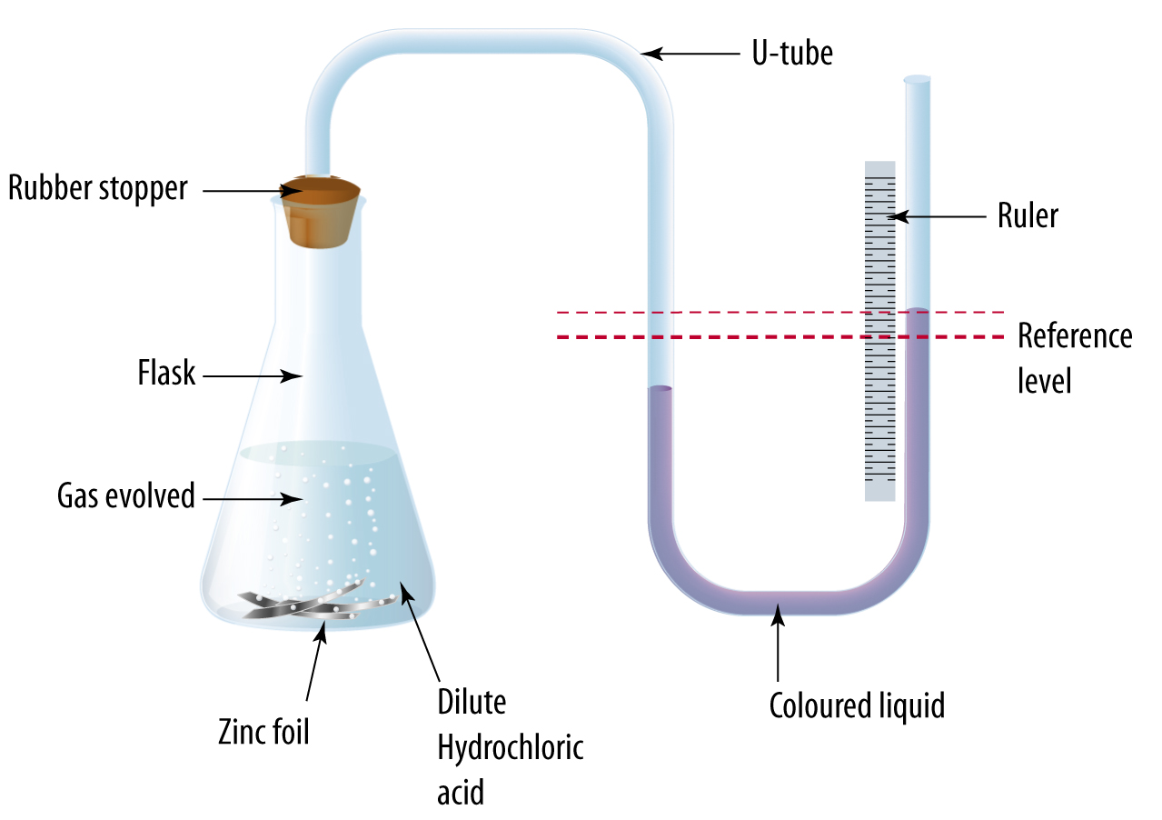
- Write a word equation for the chemical reaction occurring in the flask.
.........................................................................................................................................................
- A coloured liquid is placed in the U-tube as shown. Initially the level of the coloured liquid in each arm of the U-tube is at the reference level line.
- Why are the liquid levels initially equal?
................................................................................................................................................
- After some time, the level in the right arm has risen and the left arm has fallen as shown. Explain why this happens.
....................................................................................................................................................................................................................................................................................................
- Explain how this apparatus can be used to follow the rate of the chemical reaction ................................................................................................................................................................................................................................................................................................................
- If magnesium was used instead of zinc, what differences would be observed?
................................................................................................................................................................................................................................................................................................................

- Complete the following table. You may need to refer to the periodic table.

Element | Symbol | Electron configuration | Group | Period
Sodium | Na | 2,8,1 | 1 | 3
Fluorine
 | P
 |  | 2,2
 |  | 2,8,7
 |  |  | 18 | 4

- The following diagrams show groups of four elements of the periodic table. For each grouping, state one property or characteristic that they all share.

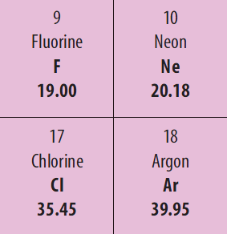
...............................................................

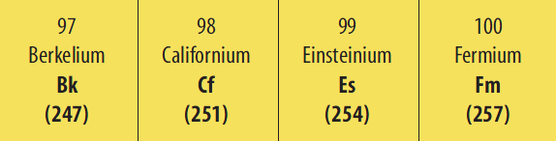
………………………………………………………………………………..

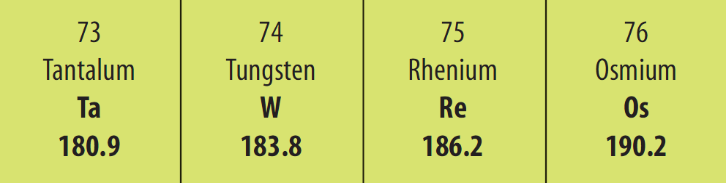
............................................................................................................................

- Complete the following table by placing the symbols of the following elements in the correct columns.
Gold | Molybdenum | Tellurium | Potassium | Silicon
Germanium | Strontium | Lead | Iodine | Radon

METALS | METALLOIDS | NON-METALS

- Draw the structural formulae for the following molecules.
- Methane (CH₄)

- Ammonia (NH₃)

- Complete the table by writing the formulae of the ionic compounds that can form by combining ions of opposite charge:
 | Ag⁺ | Ba²⁺ | Fe³⁺
NO₃⁻
S²⁻
P³⁻

- What is the valency of elements X, Y and Z in each of the compounds below?
- H₃X (ionic) .........................................................................................................
- YO₂ (covalent) .....................................................................................................
- K₂Z (ionic)...........................................................................................................

- Using the provided information, determine the chemical formulae of each compound formed from each pair of elements.
- R has an electrovalency of +3 and T has an electrovalency of –1.
…………………………………………………………………………………………………...
- M has a covalency of 2 and Q has a covalency of 3.
……………………………………………………………………………………………….......

- Using the provided information, determine the chemical formulae of each compound formed from each pair of elements.
  - D has an electron configuration of 2,8,18,8,2 and E has an electron configuration of 2,8,18,18,8,7.
.......................................................................................................................................................
- G an electron configuration of 2,8,18,18,8,1 and H has an electron configuration of 2,8,18,6.
.......................................................................................................................................................

